User Guide
To see the Steps please click this link:
ETL pipeline Demo-20251218_201327-Meeting Recording.mp4
System Setup & Execution
This section describes how to set up and run the project locally (Windows 11).
1. Prerequisites
The following software must be installed:
Python 3.10
Java JDK 17
PostgreSQL 14+
Apache Spark (local mode)
Power BI Desktop
2. Python Dependencies
From the project root directory, run:
py -3.10 -m pip install -r requirements.txt
Required libraries include:
pyspark
pandas
pyarrow
psycopg2-binary
azure-storage-blob
requests
3. Database Setup
Start PostgreSQL.
Create a database named weatherdb.
Run the SQL script in sql/create_tables.sql to create the required schema and tables.
4. Configuration
Update configuration values inside the Python scripts:
Azure Blob Storage connection string
PostgreSQL credentials
OpenWeather API key
(For security reasons, real credentials are not included in the submission.)
5. Execution Order
The pipeline should be executed in the following order:
Step 1 : Weather Data Ingestion
py -3.10 src/openweatherapi_integration.py
This step:
Calls the OpenWeather API
Stores raw JSON files in Azure Blob Storage
Step 2 : Spark-Based Data Curation
py -3.10 src/spark_hourly_to_azure_curated.py
This step:
Reads raw weather JSON from Azure
Generates hourly records
Enriches data with airport delay attributes
Produces a large curated dataset
Uploads Parquet output to Azure
Step 3 : Load Curated Data into PostgreSQL
py -3.10 src/curated_parquet_to_postgres.py
This step:
Downloads curated Parquet data from Azure
Loads it into PostgreSQL for analytics
6. Visualisation
Open Power BI Desktop.
Open the provided .pbix file.
Ensure PostgreSQL connection parameters match local settings.
Refresh the dataset to view results.
7. Expected Output
Azure Blob Storage contains raw and curated data layers
PostgreSQL contains a table with ~100,000 rows
Power BI dashboard displays interactive analytics
8. Troubleshooting
Ensure Python and Spark versions match prerequisites.
Verify Azure connection string formatting.
Ensure PostgreSQL service is running before loading data.
9. Automating scripts
please open cmd in the project directory and type "run_pipeline.bat" to run this file that executes all the above python scripts automatically with a single step.

Openweather integration to azure
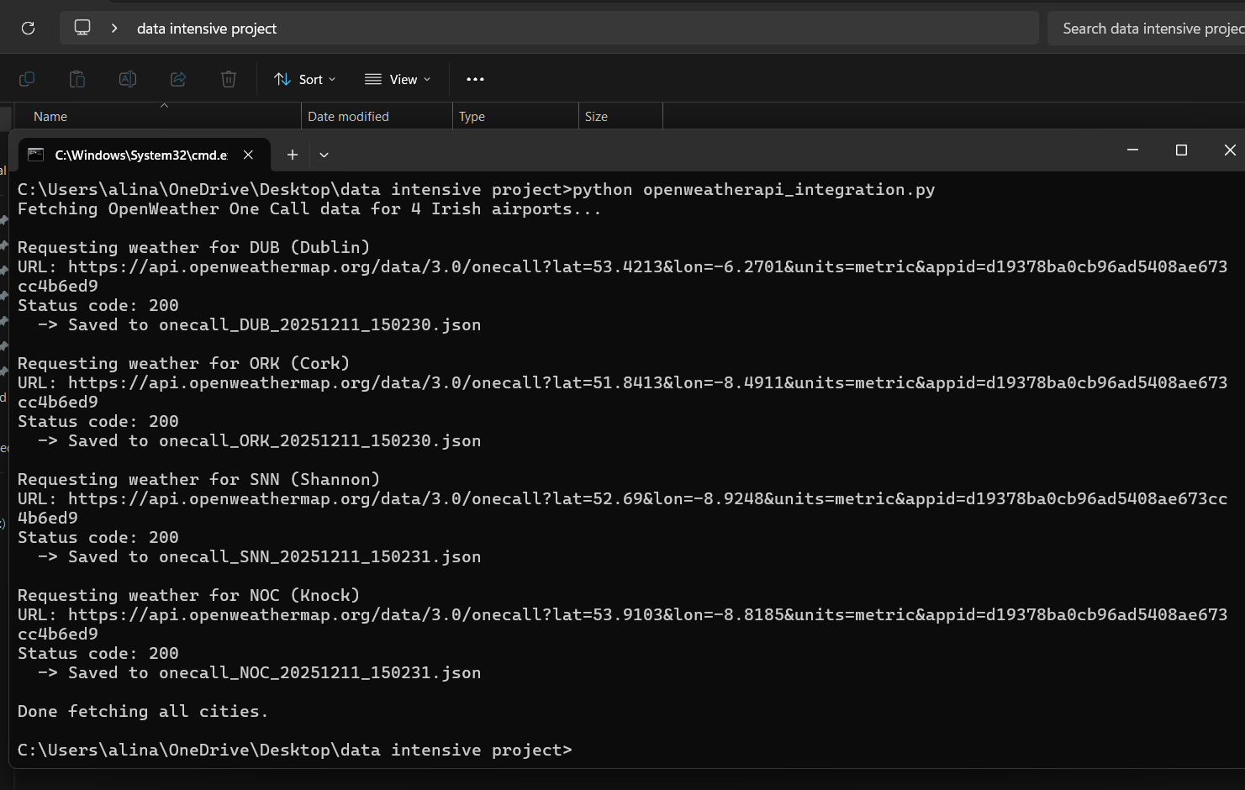
Parquet to postgreSQL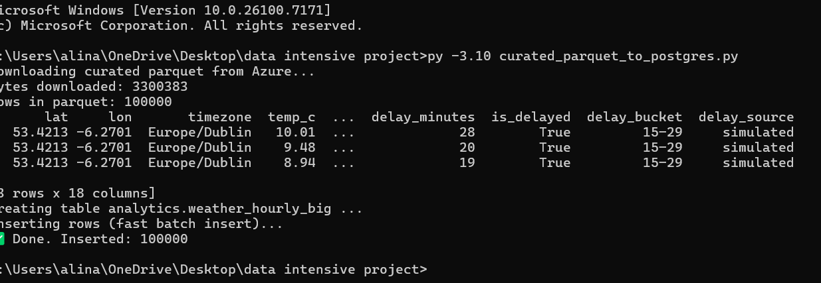
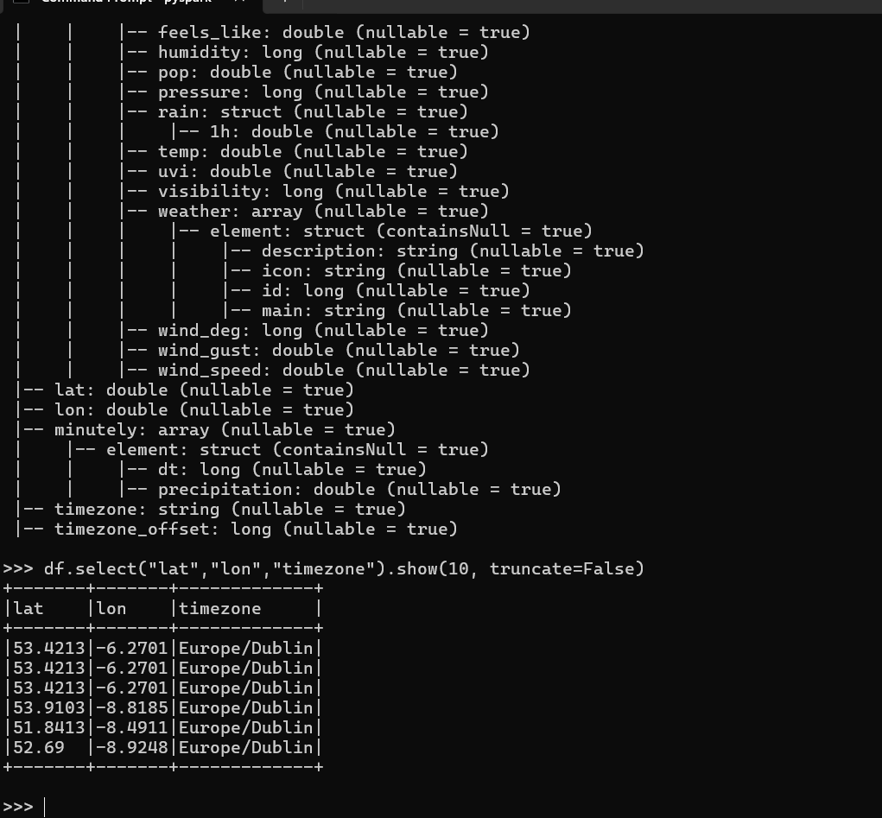
Openweather Json parameters for 4 airports

